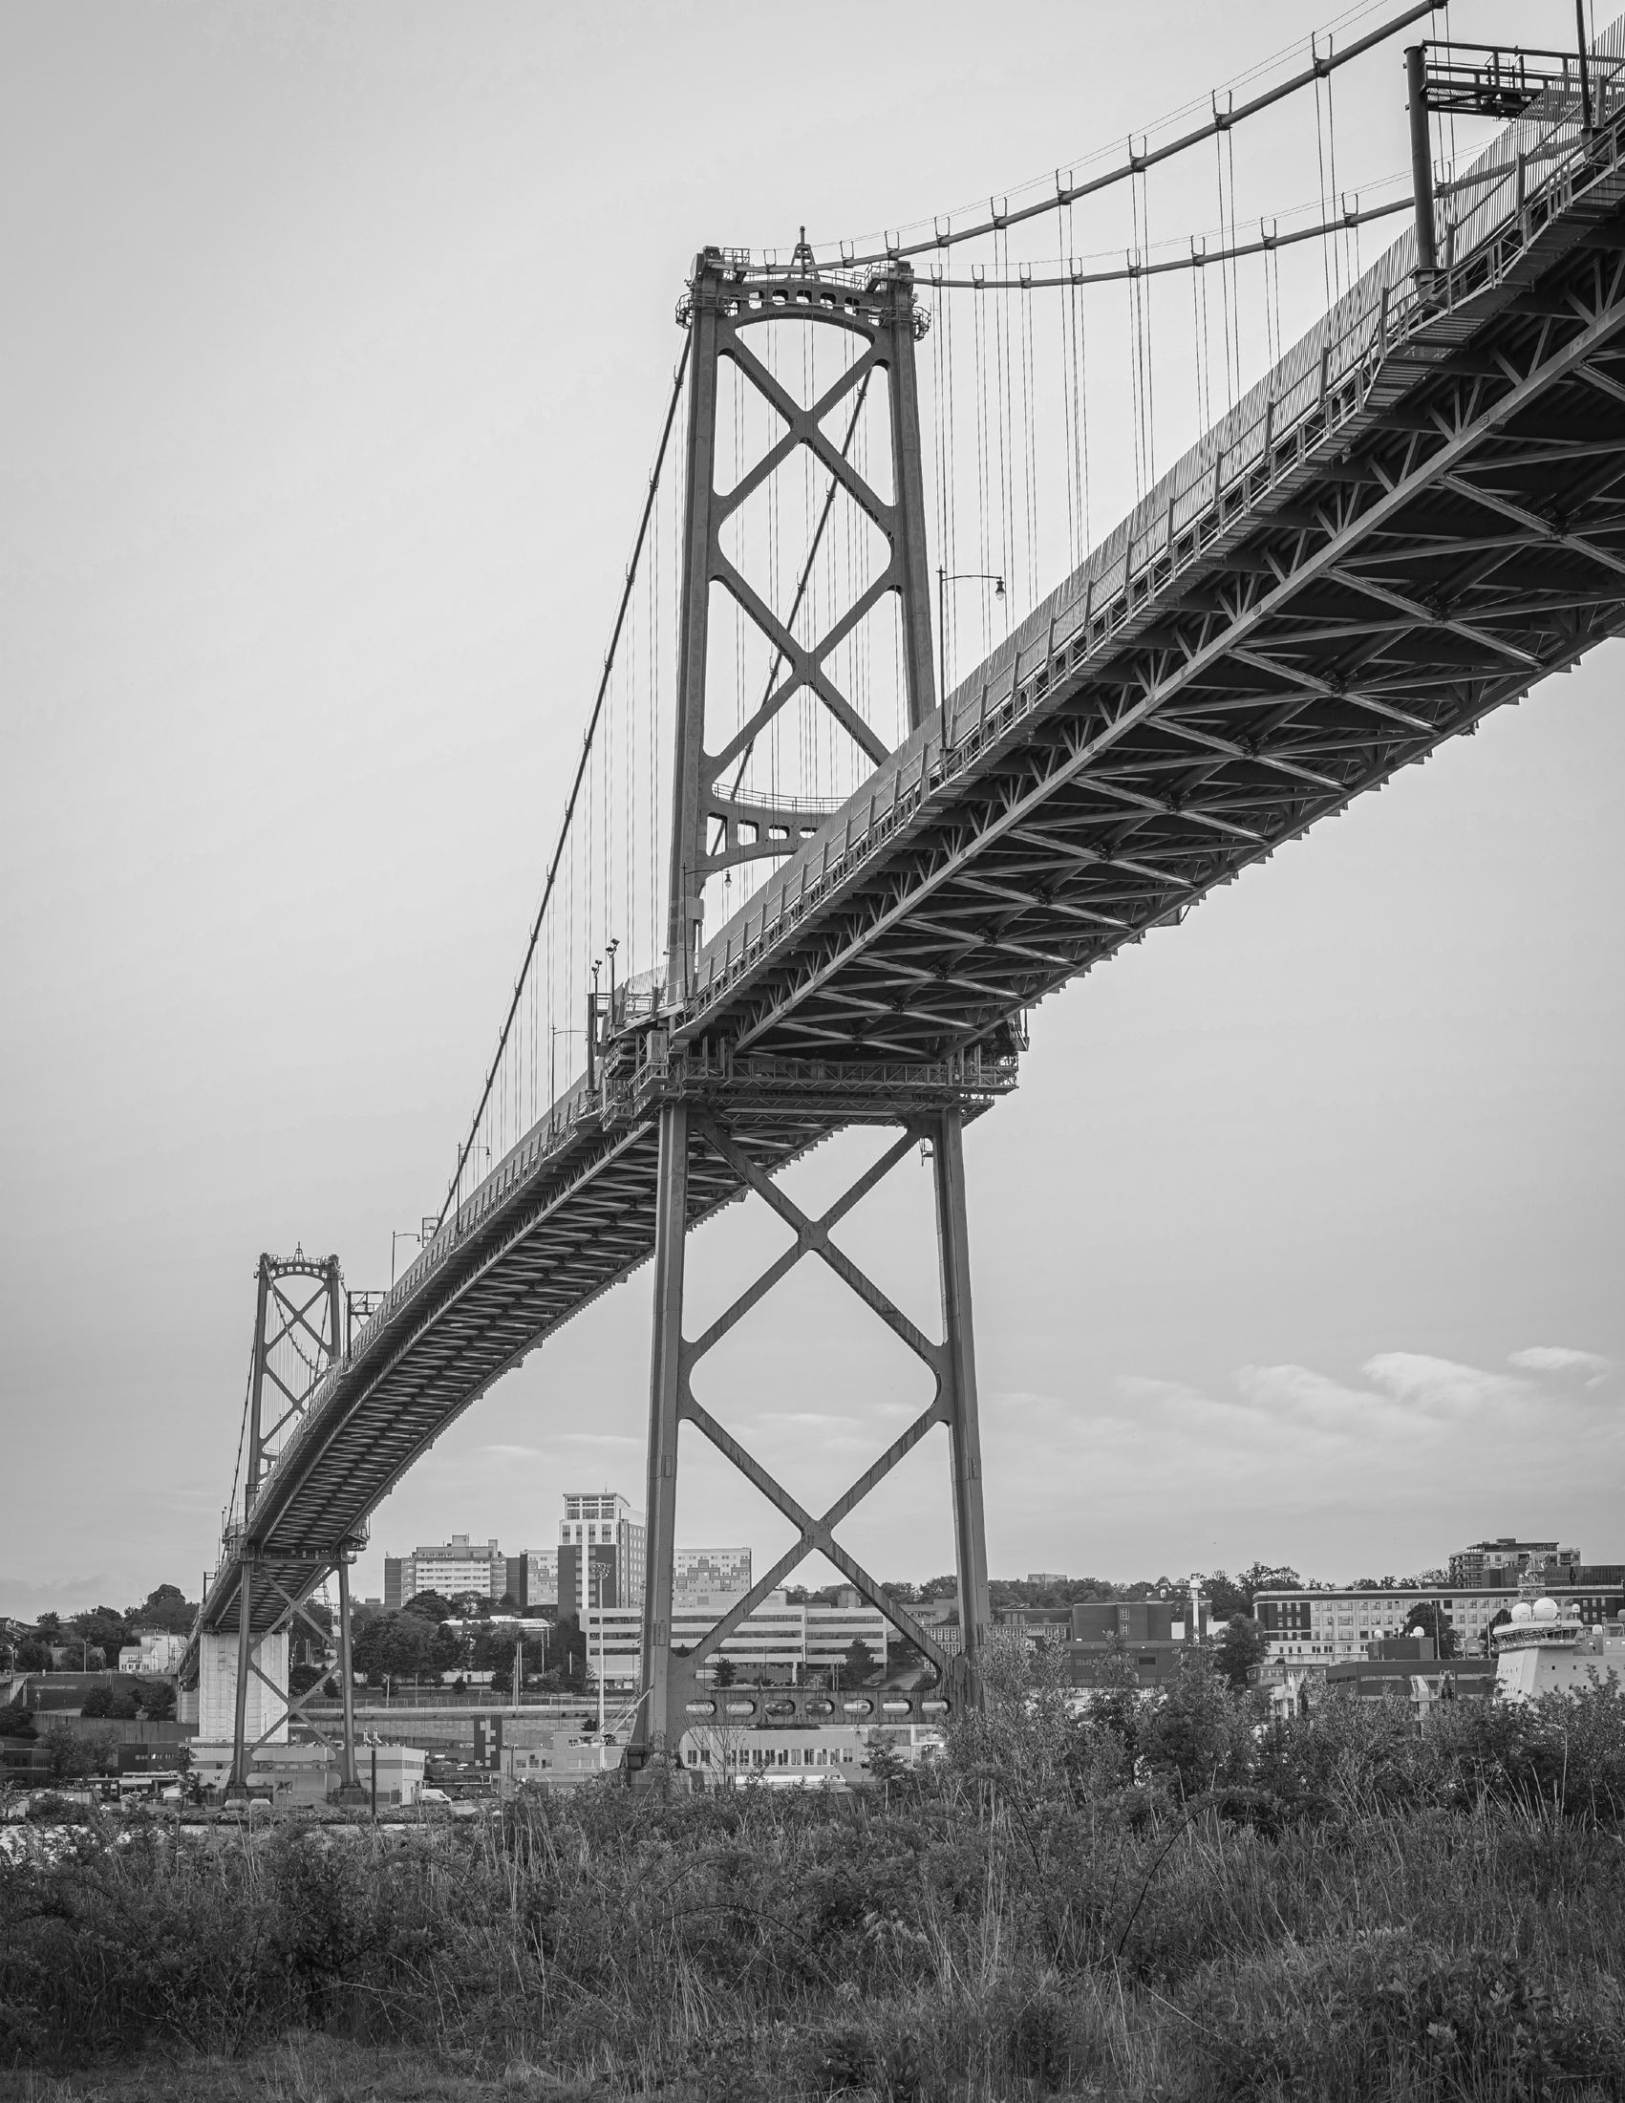


Strategic Plan

2025-2030

Halifax Harbour Bridges

Mission
To provide safe, efficient and reliable cross-harbour transportation infrastructure.

Vision
To be recognized as an industry leader for providing innovative cross-harbour transportation solutions.

Core Values
- Safety of employees and bridge users is our fundamental focus and a shared responsibility.
- Stewardship of our assets and the environment is our corporate and social responsibility.
- Respect means acting with professionalism, inclusivity, integrity and accountability.
- Collaboration and Engagement with employees, bridge users, communities, and partners drives progress toward HHB’s mission.
- Teamwork and Employee growth is supported by building on collective strengths.
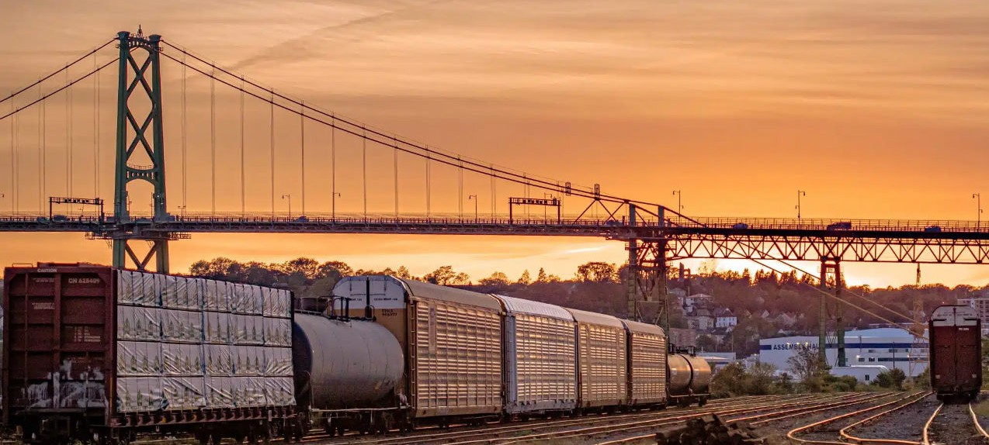
- Excellence is achieved through creativity, continuous improvement and the application of best practices.

Priorities, Goals and Key Performance Indicators

Strategic Priority 1: Taking Care of the Bridges
Operations and maintenance decisions are guided by safety, international best practices, environmental sustainability, climate resilience, and financial responsibility.

Goals
- Establish and secure government approval for the MacKay Bridge plan; complete procurement and initiate construction by 2030.
- Maintain the health and lifespan of HHB infrastructure through ongoing inspection, evaluation, planning, and investment.
- Implement modern IT systems to optimize HHB asset management and support data-driven decision-making.
- Implement a Climate Adaptation Plan that identifies and addresses high-level risks within the Asset Management Plan.
Outcomes – Success looks like….

- An evidence-informed plan, detailing the decision and plan of action, for the MacKay Bridge is being implemented, and includes procurement, establishment of a corridor, securing the land; contributing
to a regulatory framework; gaining public support through a comprehensive engagement strategy.
- Maximum value of HHB’s infrastructure is achieved by responding to the results of annual inspections
and Asset Management Planning, evaluating whether investments made are being utilized to the fullest extent possible and extending the life of HHB’s assets.
- Modern IT systems include a Computerized Maintenance Management System (CMMS) and
weigh-in-motion technology enhanced by AI capabilities.
- The Asset Management Plan reflects the reality of anticipated impacts of climate resilience,
on the bridges and all other HHB infrastructure.
- Prudent investment in HHB infrastructure, wise use of resources and financial stewardship is on
par with industry standards and monitored annually.

Strategic Priority 2: User, Community and Partner Value and Experience

Seamless, reliable, and safe bridge crossings are informed by technology; partnerships are leveraged for success and proactive communication, and engagement strategies are in place.

Goals
- Partner with the province, HRM and other collaborators to improve this important transportation corridor; facilitate & contribute expertise and leadership to key initiatives within the Regional Transportation Plan.
- Leverage data from IT systems and bridge/roadway peripheral devices to monitor and enhance user satisfaction and crossing experiences.
- Promote bridge and road safety through data analytics, infrastructure enhancements, and public engagement.
- Ensure consistent and appropriate communication with users, governments, and community groups regarding HHB initiatives.
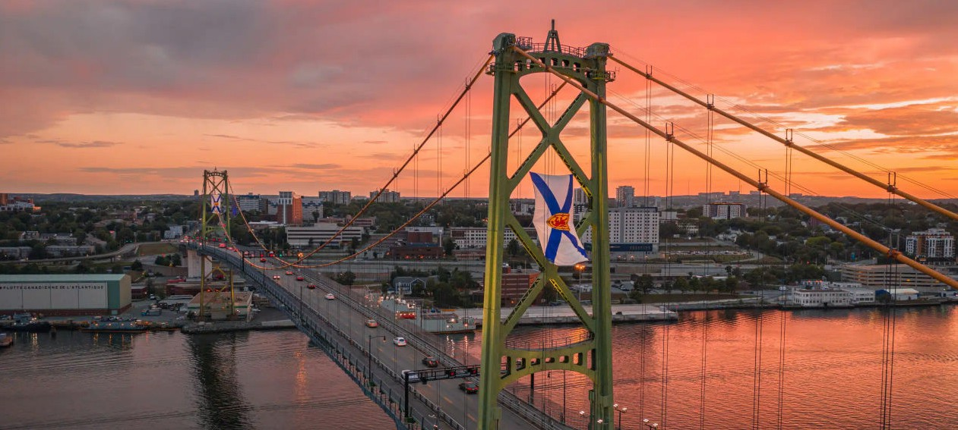

Outcomes – Success looks like..
- Bridge and road safety metrics improve, interruptions are minimized, reflected in a measurements dashboard; new technology and IT systems contribute to this improvement.
- Users, community and partners participate in and contribute to events and activities outlined in an annual engagement plan, with involvement increasing each year.
- HHB is tasked with leading initiatives outlined in the Regional Transportation Plan suited to its unique
skills and expertise.
- A calendar of planned maintenance activities is created, and up-to-date notice is provided
for bridge closures on multiple channels at least one week in advance.
- HHB is invited to speak at industry, partner and community events about bridge innovations and
key initiatives.

Strategic Priority 3: A Healthy Workplace Culture
A safe, healthy, diverse, and inclusive workplace is cultivated to support employee engagement and success.

Goals
- Engage employees in HHB’s mission, vision, and values.
- Promote a culture of physical and psychological safety that is equitable, inclusive, and welcoming.
- Provide education and training aligned with evolving workplace needs and career development goals.
- Support supervisors in helping employees understand how their roles contribute to HHB’s success.
- HHB senior staff maintain high levels of alignment and cohesiveness in their leadership.
- Continue to build a workforce that reflects the diversity of Nova Scotia’s communities.

Outcomes – Success looks like…
- Employees are engaged through regular communication, town halls, and project involvement,
understanding how what they do contributes to the work and reputation of HHB.
- HHB maintains or exceeds a rating of 95% on its Occupational Health and Safety Audit and acts on the recommendations.
- HHB’s workforce diversity demographics become more representative of the communities served in Nova Scotia.
- All HHB employees contribute meaningfully to discussions about their work, the identification of issues
and the future of HHB due to improvements in psychological safety and inclusivity.
- HHB senior staff demonstrate alignment and cohesiveness in their leadership.
- Employees receive consistent feedback and are engaged in discussions to identify educational and developmental opportunities that support their career objectives, employee growth, training opportunities and succession planning.

