



Halifax Harbour Bridges
2025 – 2026 Annual Report
Table of Contents
Message from the Chair and CEO 3
Project LifeSpan: securing the future of the Macdonald Bridge 4
Completing a critical renewal: Macdonald Bridge bearings replacement 5
Halifax Harbour Bridges adapts and evolves 6
Building the future of bridge operations 7
VMS brings time-to-destination travel information to HRM 8
Changes at the MacKay Administration Building and garage 9
Raising the standard: enhancing visibility, enhancing safety 10
Building strong community connections 12
Celebrating community on the bridges 14
Financial Summary 15

Message from the Chair and CEO
The 2025–26 fiscal year marks the beginning of a new chapter in the history
of Halifax Harbour Bridges.
For more than seven decades, HHB has connected communities, supported economic growth, and provided safe and reliable transportation across Halifax Harbour. This year, the organization also continued one of the most significant transformations in its history.
The transition to toll-free crossings on the Angus L. Macdonald and A. Murray MacKay bridges changed a system that had been in place for generations. At the same time, legislation was introduced to dissolve the Halifax-Dartmouth Bridge Commission and integrate Halifax Harbour Bridges into Link Nova Scotia, ending the role of the Board of Commissioners. These changes represent a new model for delivering transportation infrastructure in Nova Scotia while preserving the expertise, knowledge, and commitment that define HHB.
As Board Chair and CEO, we are proud of how employees across the organization embraced this transition. Their professionalism, adaptability, and dedication ensured that service to the travelling public remained uninterrupted while significant operational, technological, and organizational changes were underway. We also want to thank the members of this Board of Commissioners and past board members for their commitment and guidance to HHB.
Throughout this time, we remained focused on the future. Major maintenance and rehabilitation work continued with investments in infrastructure renewal, bridge preservation, traffic management, and long-term planning. Readers can learn more about these projects in this annual report.
As HHB becomes a division of Link Nova Scotia, the bridges remain as important as ever to the daily lives of Nova Scotians and to the economic vitality of our region. The governance structure is changing, but the mission is not. The infrastructure, systems, and people that keep Halifax moving will continue to evolve, while our commitment to safety, reliability, and public service remains unchanged.
We would like to thank the hundreds of thousands of people who use the bridges each week for their continued support and confidence.


Respectfully submitted,
Vicki Harnish
Chair,
Board of Commissioners
Tony Wright
Chief Executive Officer

Project LifeSpan:
Securing the future of the Macdonald Bridge

Halifax Harbour Bridges (HHB) has successfully completed Phase 1 of Project LifeSpan, which focused on the Dartmouth Tower. This work involved carefully blasting away decades of paint, inspecting and repairing the steel, and applying a new three-layer protective coating. To ensure safety and protect the harbour, nearby traffic, and surrounding properties, the Dartmouth Tower was fully wrapped during work to contain paint and debris—an approach that will continue
in Phase 2.
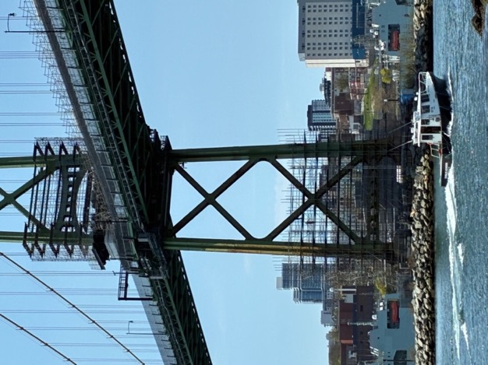
Phase 2, which began in March 2026, focuses on the Halifax Tower. An overhead platform has been constructed to provide safe access for steel rehabilitation and recoating, continuing the approach established in Phase 1. Phase 2 is expected to be complete by the end of 2026.
“We’re very pleased with the way this project is progressing,” said Project manager Walter Watkins. “Removing 70 years of paint allowed us to inspect the steel up close and address any hidden corrosion. The new three-layer protective coating will help safeguard the Dartmouth Tower from the harsh salt environment for decades to come.”
This $70-million initiative is the fourth phase of a multi-year program to renew the Macdonald Bridge’s protective coating system, following the successful completion of the first three phases. Project LifeSpan includes the rehabilitation of original steel at the main towers, Bent D1, and the Dartmouth Approach Truss, ensuring the bridge remains safe, reliable, and operational for the next 50 years or more.
HHB is committed to supporting Canadian and Nova Scotian suppliers and contractors throughout this project. The project was awarded to Liberty Blast Tech and most of the $70 million budget (more than $47 million) will be directed to Canadian firms, with substantial participation from local companies. Most of the workforce is Canadian, and the majority of materials is sourced locally, reflecting HHB’s dedication to strengthening the regional economy while delivering essential infrastructure improvements.

Completing a critical renewal:
Macdonald Bridge bearings replacement

A major long-term rehabilitation project on the Angus L. Macdonald Bridge reached an important milestone in January 2026 with the completion of the Bearings Replacement Project—an effort that began in 2014.
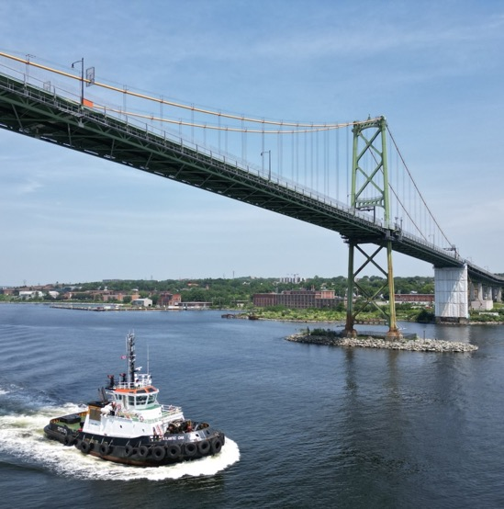
The project involved removing old bridge bearings, many of which were original components installed when the bridge was built in 1955. Though unseen by the public, bearings play a vital role in the bridge’s performance and longevity. They allow the structure to expand and contract safely in response to temperature changes, traffic loads, and environmental conditions, preventing unnecessary stress and damage to the suspension bridge.
Through this multi-year renewal, Halifax Harbour Bridges has significantly improved the bridge’s ability to function as designed while extending the service life of this vital transportation link. The completion of the bearings replacement represents another important step in preserving the Macdonald Bridge for future generations.

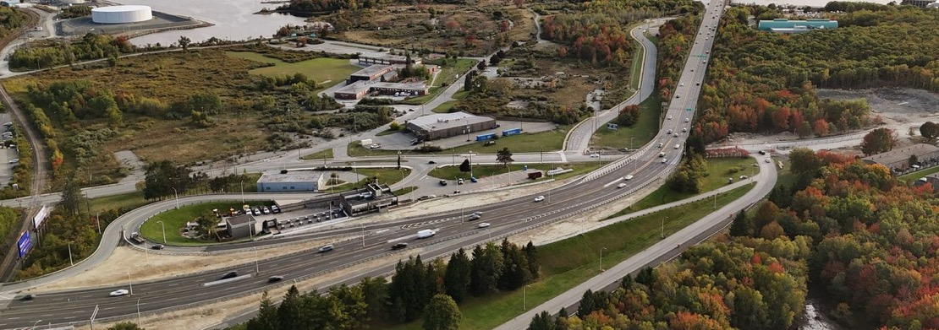
Halifax Harbour Bridges adapts and evolves

On March 17, 2025, Halifax Harbour Bridges (HHB) marked a historic milestone: the removal of tolls on both the Angus L. Macdonald and A. Murray MacKay bridges. A year later, HHB continues to adapt, demonstrating our commitment to safe, efficient crossings
for all users.
Total traffic volumes have increased by 10.2 per cent compared to pre-toll levels with 37.2 million crossings. It is important to note that traffic on the bridges has continuously increased over recent years and multiple factors —including population increase and return-to-office policies replacing work-from-home — may also be contributing to the increase in the number of vehicles using
the bridges.
HHB has begun collecting data to better understand pedestrian and cycling use across Macdonald Bridge. From April 2025 to March 31, 2026, pedestrian crossings totaled 60,566, while 63,254 bicycle crossings were recorded. Due to technical difficulties with February counts, the actual number of pedestrian crossings is likely somewhat higher
than recorded.
Early safety indicators since toll removal are promising. The total number of accidents on the bridges has decreased by approximately 40 per cent, and incidents are no longer concentrated around the former plaza bottlenecks. This shift reflects not only the removal of toll booths, but also the ongoing redesign of bridge lanes aimed at enhancing flow and minimizing conflict points.
Looking ahead, HHB is working closely with Halifax Regional Municipality and the Province of Nova Scotia on long-term congestion management strategies. Permanent lane redesign and traffic optimization measures are under development to ensure that both bridges continue to operate efficiently and safely as travel patterns evolve.

Building the future of bridge operations

Work is underway on Halifax Harbour Bridges’ new Traffic Management Centre (TMC), a state-of-the-art facility that will transform how HHB manages day-to-day bridge operations. Located at 471 Prince Margaret Boulevard in Dartmouth, the former MACPASS Customer Service Centre is being repurposed as a centralized hub to strengthen coordination, improve efficiency, and support safe, reliable cross-harbour travel—24/7.
The TMC will bring together operations staff from both the Macdonald and MacKay
bridges under one roof, enhancing collaboration, reducing redundancy,
and streamlining communication.
“This project is about building a smarter, more connected future for bridge operations,” said David Greenfield, HHB Chief Information Officer. “By integrating our teams and systems in one location, we’re setting the stage for more reliable service, faster response times,
and stronger collaboration across
the organization.”
As HHB’s operational nerve centre, the TMC will support traffic monitoring and control, Bridge Patrol dispatch, emergency call handling, incident tracking, third-lane reversals on the Macdonald Bridge, and customer communications including VMS messaging. It will also accommodate appointments with customers and contractor services, centralizing the tools and people needed to keep traffic moving safely and efficiently.
Inside the building, demolition and construction are underway to install upgraded workstation consoles, a video display wall, and advanced monitoring and communication systems. Looking ahead, the TMC positions HHB to collaborate with Halifax Regional Municipality and the Province as part of regional transportation initiatives, supporting the broader goals of Link Nova Scotia’s Regional Transportation Plan.
Early planning targets a transition to the TMC in late 2026, pending budget approval and other factors. Once complete, the TMC will provide a modern, high-tech foundation for safe, responsive, and coordinated bridge operations well into the future.



VMS brings time-to-destination travel information to HRM

By December 2025, Halifax Harbour Bridges completed the full implementation of travel time messaging on 11 Variable Message Signs (VMS) across Halifax Regional Municipality — helping drivers make more informed route choices before reaching the Macdonald and MacKay bridges.
Located on major routes leading to the bridges, including Highway 101 (Lower Sackville), Highway 102 (Miller Lake and Bayers Lake), and Highway 118 (Dartmouth Crossing), the signs now display real-time time-to-destination information, giving drivers a clearer picture of how long their trips will take.
The system uses Bluetooth and Wi-Fi sensors to match anonymous signals between key locations to calculate average travel times.
All signs are centrally managed 24/7
from HHB’s Operations centre, ensuring continuous oversight.
The result is improved traffic flow, better driver decision-making, and enhanced road safety
—particularly during peak periods, construction, weather events, and incidents. Beyond travel-time information, the Variable Message Signs also remain a critical tool for sharing urgent public safety information, including woods entry and burn bans.
As this VMS system becomes part of everyday travel across HRM, HHB will continue working with Provincial and HRM partners to ensure consistent messaging and integration with broader transportation strategies.

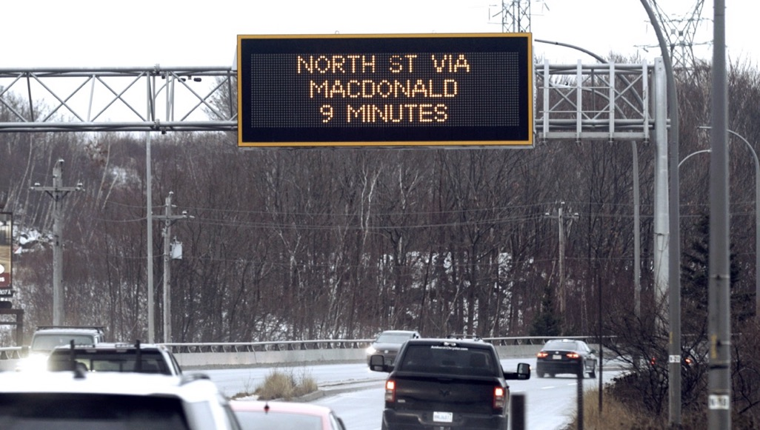

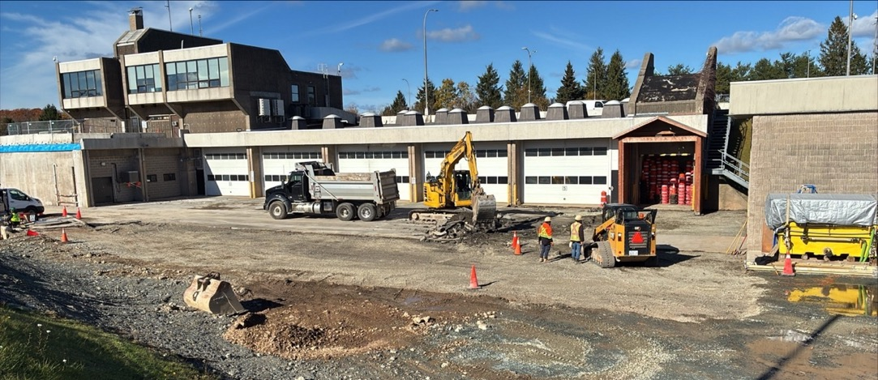
Changes at the MacKay Administration Building and garage

This year marked a significant transformation for the MacKay Administration Building and garage—enhancing the functionality of a key Halifax Harbour Bridges (HHB) operations site.
A major change included the demolition of the rear access ramp, opening space to better support site operations. Both the front and rear parking areas have been expanded and fully repaved, creating improved access and additional capacity for HHB’s growing fleet of maintenance vehicles. These upgrades help ensure crews and equipment can be
deployed efficiently to support bridge operations and maintenance.
New fencing has also been installed around the property, enhancing site security and safeguarding critical infrastructure and equipment, while steps that once connected the parking area to the operations centre have been removed.
Inside the building, work is ongoing to further strengthen HHB’s operational capacity. Additional office space is being created for
the internal inspection team — supporting
the specialized work required to monitor
and maintain the long-term health of the harbour bridges.
Together, these upgrades represent
an investment in infrastructure that helps to support the people, equipment, and expertise behind HHB’s operations.

Raising the standard: enhancing visibility, enhancing safety

Drivers crossing the harbour may have noticed something different this year – more bright colours on our bridges than ever before, and not just the iconic orange cables. That increased visibility is no coincidence. It reflects a deliberate step forward in how Halifax Harbour Bridges (HHB) approaches safety.
At HHB, safety is more than a requirement – it is a shared responsibility and a core value that guides every decision we make.
In early spring 2026, HHB took a significant step forward in strengthening that commitment by updating our Personal Protective Equipment (PPE) policy for high-visibility apparel.
For many years, the standard for workers – both HHB personnel and contractors – was CSA Class 1 high-visibility apparel, typically consisting of striped garments with a black background. “While compliant with minimum requirements, this approach did not fully reflect the complex and high-risk environments in which our teams operate every day,” said HHB Safety Manager Lori Jardine. “From working in and around live traffic on our bridges to operating in active construction zones with heavy mobile equipment and cranes, visibility is critical – not just for workers, but for motorists, pedestrians, and all users of our infrastructure.”
Recognizing this gap, HHB undertook a review of our visibility standards through a risk-based lens. The conclusion was clear: to better protect our workforce and the public, we needed to go beyond minimum compliance and raise the bar.
As a result, HHB implemented a new requirement for CSA Class 2 Level 2 high-visibility apparel across all operations. This change ensures that anyone working for or on behalf of HHB is equipped with enhanced visibility garments designed for higher-risk environments, where greater conspicuity is essential. The new standard significantly increases the amount of fluorescent background material and reflective striping, improving worker visibility in a wide range of conditions – from daylight to low light, and in variable weather.
The impact of this change is immediately visible. A side-by-side comparison of the previous Class 1 apparel and the new Class 2 gear highlights a clear and meaningful improvement. Workers are now more easily seen from greater distances and from multiple angles – an essential factor when operating in dynamic environments where conditions can change rapidly.
This initiative reflects HHB’s proactive approach to safety – anticipating risks and taking decisive action to address them. By elevating our PPE standards, we are not only enhancing protection for our own people, but also reinforcing safety for contractors, partners, and the thousands of individuals who rely on our bridges every day.

At its core, the move to CSA Class 2 Level 2 high-visibility apparel is about visibility in every sense of the word: being seen, being prepared, and being committed to continuous improvement. It is one more example of how HHB is building a safer, stronger future
– where every worker goes home safe, and every crossing is supported by the highest
standards of care.
As we look ahead, we remain focused on identifying opportunities to enhance safety across all aspects of our operations. Because at HHB, raising the standard isn’t a one-time change – it’s an ongoing journey.

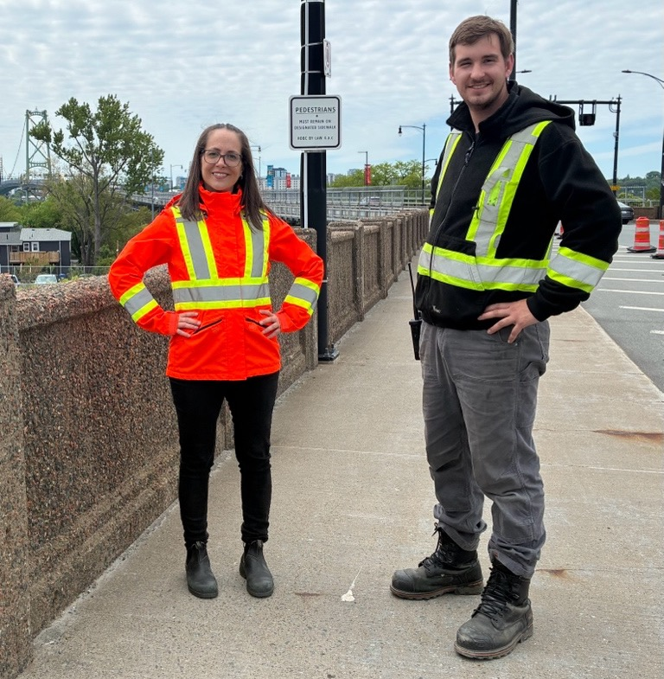

Building strong community connections
Guided by our core value of community engagement, Halifax Harbour Bridges actively supports initiatives that bring people together, strengthen local organizations, and create lasting community impact.

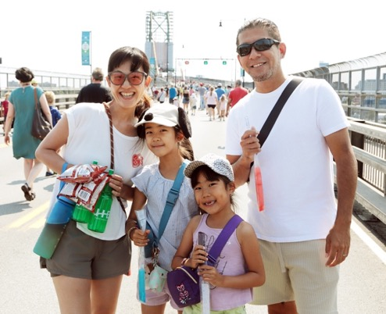
HHB’s events on Natal Day Weekend continue to be a cornerstone of public engagement efforts. In 2025, approximately 8,000 people and more than 30 community organizations participated in Bridgewalk, transforming the Angus L. Macdonald Bridge into a vibrant gathering place for residents and visitors. Each year, this event offers the opportunity to experience the bridge on foot, reinforcing the bridge’s role as a shared community asset and a symbol of connection.
Natal Day Weekend 2025 also marked the final running of MACPASS Miles, a long-standing bridge race that combines physical activity with charitable giving. All proceeds from registration fees (only paid by adults; children and youth always run free) were donated to HHB’s Key Partner for the year. In 2026, the event will continue under its new name, Harbour Hustle, building on the strong legacy established by MACPASS Miles.
“When we open the bridges for events like Bridgewalk and MACPASS Miles, we’re creating space for people to connect with each other and with infrastructure that plays such
an important role in their daily lives,” said Steven Proctor, Communications Manager.

HHB’s Key Partner Program focuses on fundraising and awareness efforts on one local charitable organization each year, allowing HHB employees and event participants to support a shared cause in a meaningful way.
In 2025, Big Brothers Big Sisters of Greater Halifax served as HHB’s Key Partner, receiving funds from MACPASS Miles as well as additional contributions from in-house fundraising initiatives led by HHB employees. Together, these efforts supported mentoring programs that help young people build confidence, resilience, and strong
community connections.
“The Key Partner Program allows
us to focus our efforts in a way that’s meaningful and measurable,” Proctor said. “It’s about building strong relationships and making a real difference in the community.”
For the coming fiscal year, HHB is pleased to announce The North Grove as its new Key Partner. The organization’s work to strengthen children, families, and communities aligns closely with HHB’s values, and HHB looks forward to supporting its mission through collaborative fundraising and
engagement initiatives.



Celebrating community on the bridges

Halifax Harbour Bridges is proud to support community organizations by offering opportunities to recognize milestones, causes, and achievements using some of the region’s most recognizable and visible infrastructure.

In 2025, the MacKay Bridge garden logo program helped two organizations celebrate important milestones, providing a unique and meaningful way to mark anniversaries and accomplishments in a highly visible setting: the 150th anniversary of YWCA Halifax and the 80th anniversary of the not-for-profit Association of Chartered Professionals in Human Resources Nova Scotia (CPHR).
HHB also continued its Macdonald Bridge banner program, which runs annually from May through the end of September. The program allows community groups to display banners recognizing events, awareness campaigns, and organizational milestones. In 2025, 22 community organizations participated in the program, each with six banners that hung
along the Macdonald Bridge deck for
two-week periods.
“These initiatives recognize that the bridges are shared public spaces,” said Communications Manager Steven Proctor. “They’re about celebrating the people, causes, and events that matter to our community.”

Commentary

Revenue
This was Halifax Harbour Bridges first year of Provincial grant funding. The capital grant funding
was under budget with delays in some projects, although the Macdonald Steel Repairs and Coatings project was ahead of schedule.

Expenses
Administration expenses were lower than estimate with reductions in training and consulting,
offset by the addition of an office space lease due to a change in accounting standards.
Operating expenses were below estimate due to savings in bank charges, IT licenses, and unrealized MACPASS expenses.
Maintenance expenses were lower than estimate with lower engineering consulting fees than planned due to the timing and scope of work. These savings were offset by increases in vehicle repairs and bridge maintenance.
Amortization is lower than estimate due to the timing of completion of certain projects.
Impairment expense was not included in the estimate and is primarily the retirement of the MACPASS credit card tokenization system.

Financial Summary
 | 2025-2026 Actuals | 2025-2026 Estimate
 | ($ in thousands) | ($ in thousands)
Revenue
Provincial Operating Grant | 14,711 | 15,000
Provincial  Capital Grant | 68,630 | 85,900
Other income | 665 | 466
Total revenue | 84,006 | 101,366
Expenses
Administration | 3,784 | 4,014
Operating | 4,782 | 4,860
Maintenance | 5,423 | 7,192
Amortization | 12,308 | 14,529
Impairment | 14 | -
Total expenses | 26,311 | 30,595
Annual Surplus | 57,695 | 70,771

